# CS 255 Business Requirements Document Template

Complete this template by replacing the bracketed text with the relevant information.

This template lays out all the different sections that you need to complete for Project One. Each section has guiding questions to prompt your thinking. These questions are meant to guide your initial responses to each area. You are encouraged to go beyond these questions using what you have learned in your readings. You will need to continually reference the interview transcript as you work to make sure that you are addressing your client’s needs. There is no required length for the final document. Instead, the goal is to complete each section based on your client’s needs.

**Tip:** You should respond in a bulleted list for each section. This will make your thoughts easier to reference when you move into the design phase for Project Two. One starter bullet has been provided for you in each section, but you will need to add more.

## System Components and Design

### Purpose

*What is the purpose of this project? Who is the client and what do they want their system to be able to do?*

* The purpose of this project is to create software for a company that offers training to drivers, DriverPass, that handles the majority of their business needs.
* Broadly, they want the system to:
  + be able to be used over multiple operating systems and devices
  + synchronize data across said devices
  + have this data be available on demand over a cloud-based service

### System Background

*What does DriverPass want the system to do? What is the problem they want to fix? What are the different components needed for this system?*

* DriverPass wants to create software that enables the following features:
  + Scheduling of driver training
  + compatibility with PCs and mobile devices
  + download to common file types (such as CSV or excel)
  + synchronization with DMV for training updates
  + back up to a cloud database
  + user login system for security
  + administrative level controls to manage said access across multiple users
  + change tracking for users with printable reporting
  + customer login to manage scheduling online and a self-service password reset system
  + three packages that allow differing amounts of scheduling times to users
  + ability to disable packages as needed
  + a training portal for users who opt in for a premium package
  + fields for event creation

### Objectives and Goals

*What should this system be able to do when it is completed? What measurable tasks need to be included in the system design to achieve this?*

* The system should essentially be a ‘one stop shop’ for their day-to-day business needs. The only three things this system won’t be doing are answering the telephone, sending and responding to email, and driving the cars. The realistic approach is to break the requirements down into tasks that need to be completed in order for a system to be realized.
  + Selecting a language/program that allows simplified output into multiple operating system formats
  + Database systems to handle users, schedule events, change tracking, packages
  + Creation of a graphical user interface for different workflow phases
    - Event management
    - User management
    - Change tracking management
    - Customer interface for scheduling
    - Customer interface for training
    - Training interface management
    - Document download
  + Synchronization of environments
    - Cloud server
    - PC Compatibility
    - iOS Compatibility
    - Android Compatibility
    - Web domain for customer login
    - DMV news releases

## Requirements

### Nonfunctional Requirements

*In this section, you will detail the different nonfunctional requirements for the DriverPass system. You will need to think about the different things that the system needs to function properly.*

#### Performance Requirements

*What environments (web-based, application, etc.) does this system need to run in? How fast should the system run? How often should the system be updated?*

* System needs to be accessible over mobile devices and computers. In order to minimize development time and costs, system could meet these requirements by being solely browser based as opposed to developing multiple programs/applications using different development tools and languages.
* System will need to run fast enough to provide a seamless browsing experience barring unusual internet delays. This would necessitate a dedicated web host for hosting the browser-based program and a domain name.

#### Platform Constraints

*What platforms (Windows, Unix, etc.) should the system run on? Does the back end require any tools, such as a database, to support this application?*

* The system would need to be functional on iOS, Android, and Windows devices at a minimum. Again, developing the system as a browser-based application would achieve system goals in a far less costly way than the alternative solutions.
* The back end would require a domain name, a dedicated web hosting service, and a browser-based program, user database, and appointment database hosted on the web host’s server. Depending on the particulars of the agreement with the web host service chosen, DriverPass might additionally need to purchase its own physical server hardware with multiple terabyte SSD hard drives configured for RAID 1 and a 10-gigabit network card.

#### Accuracy and Precision

*How will you distinguish between different users?* *Is the input case-sensitive? When should the system inform the admin of a problem?*

* Different users will have differing designations in the user database. Broadly, you would need an admin user group, a maintenance user group, a clerical user group, and a customer user group.
* From a design perspective, I would probably want a code to strip input for case differences to prevent issues from multiple accounts that are phonetically similar (tonysmith, TonySmith, etc.). The code would convert capital letters to lowercase letters and enter the stripped version into the database.
* Change tracking is mentioned in the interview transcript as a goal of the system design. Beyond normal error reporting, the system might track if a user makes an unusual number of changes. For example, if a clerical worker deletes over a certain amount of appointments in the course of a day, or if a customer purchases more than one module. Admin users should be able to specify these amounts in a system settings menu and alter them or turn them off based on the needs of the business.

#### Adaptability

*Can you make changes to the user (add/remove/modify) without changing code? How will the system adapt to platform updates? What type of access does the IT admin need?*

* Users will need to be modifiable in different ways based on the needs of the business. Customers will reasonably need to be able to make their own users and update their particulars like their password as needed. The admin and maintenance role will probably need the rights to add/modify/delete users as needed.
* System changes would happen at the speed of the internet. A single version of the user database and the appointment database will exist on the web host server. The only limiting factor would be the network/internet connections which are only reasonably controllable for the web host’s side. Updates to the system software over time would be similar to publishing a change to a web page and should not require significant downtime.
* The IT Manager Ian would reasonably need the rights to add/modify/delete users as needed save users with the admin role, review change tracking logs as needed, and change general settings for system alerts.

#### Security

*What is required for the user to log in? How can you secure the connection or the data exchange between the client and the server? What should happen to the account if there is a “brute force” hacking attempt? What happens if the user forgets their password?*

* Users will require a username and password to log in.
* Ideally, system input, output, and databases will be encrypted with a quantum proof encryption method such as AES 256 or something similar.
* Brute force attack methods using modern computer systems are ineffective against AES 256. Historically, Moore’s law has demonstrated that modern encryption tends to stay protective for roughly 30 years, however, it is unclear how quantum computing will translate with respect to computing speeds and encryption, so this rate may begin to differ once practical quantum computing is realized.
* The interview transcript specifies users should have the capability to reset their own passwords. This would probably be best accomplished by allowing a self-service functionality such as emailing an unlock code to the email address associated with the user in the database.

### Functional Requirements

*Using the information from the scenario, think about the different functions the system needs to provide. Each of your bullets should start with “The system shall . . .” For example, one functional requirement might be, “The system shall validate user credentials when logging in.”*

* The system shall:
  + Access data from anywhere online.
  + Allow documents to be downloaded from the database in common file formats (csv, pdf, etc.).
  + Allow for different user rights and roles.
  + Handle change tracking for review.
  + Allow customers to make reservations.
  + Manage appointments and track what driver goes with which customer.
  + Allow purchase of three separate pre-defined modules.
  + Disable modules if they no longer match business needs.
  + Handle clerical reservations with multiple inputs.
  + Self-service password resets.
  + Connect with the DMV website and notify on compliance changes.
  + Display the described layout when customers login.

### User Interface

*What are the needs of the interface? Who are the different users for this interface? What will each user need to be able to do through the interface? How will the user interact with the interface (mobile, browser, etc.)?*

* The interface will display the DriverPass logo, the user’s online test progress, the user’s information for their database entry, the driver’s notes which are essentially time keeping and comments on the lessons in a table format, special needs the user has, the driver’s photo, and the student’s photo.
* The user will have a method to contact DriverPass through the interface page per the interview transcript.
* The page will be browser based and accessible to any device capable of internet browsing. On a PC, the user will click with a mouse. On a mobile device, the screen will register clicks based on touch.

### Assumptions

*What things were not specifically addressed in your design above? What assumptions are you making in your design about the users or the technology they have?*

* I am making an assumption that a browser-based program would best meet the design needs for the lowest development cost. The user may have an unexpressed desire that would necessitate different development needs, such as the deployment of a mobile application for GPS tracking of customers to facilitate client pick-ups.

### Limitations

*Any system you build will naturally have limitations. What limitations do you see in your system design? What limitations do you have as far as resources, time, budget, or technology?*

* As previously stated, a browser-based program would be limited by the network and internet speeds connecting the user to the web host.
* The browser-based approach is a compromise to me as developing and deploying iOS, Android, and Windows based applications would more than likely triple the development cost without adding significant functionality with consideration to the stated design goals.

### Gantt Chart

*Please include a screenshot of the GANTT chart that you created with Lucidchart. Be sure to check that it meets the plan described by the characters in the interview.*

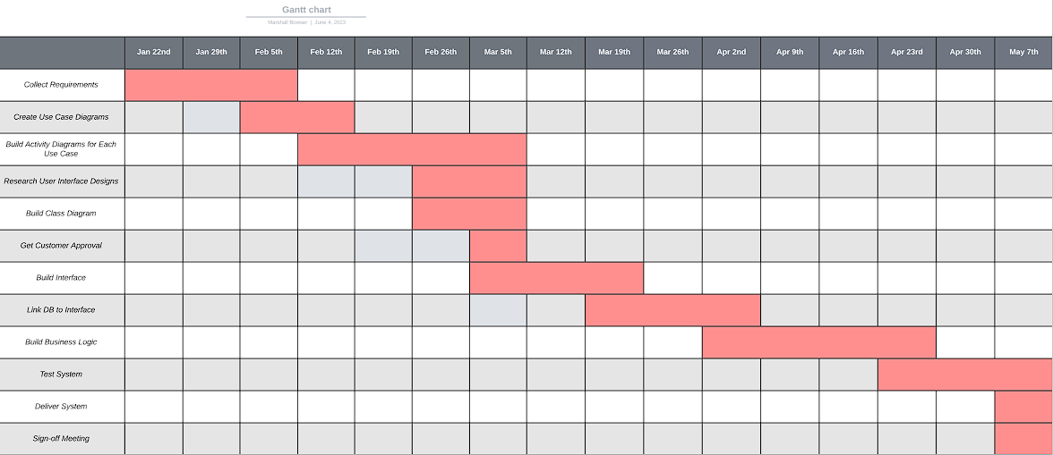

https://lucid.app/publicSegments/view/d300919e-0bb7-4e9e-9687-08097247081f